**WISN Loader**

**System Documentation**

P:\Logos\IH_LogoProffPrinting.tif

**Table of contents**

1. **Introduction**
2. **System requirement**
3. **Using WISN Loader**
   1. File structure
   2. Running the application
   3. Sorting the facilities
4. **Managing templates, activities, facilities**
   1. Managing Templates
   2. activities
   3. facilities
5. **Introduction**

The Workload Indicators of Staffing Need (WISN) software application is a tool for using a computer to record, analyze, and report data related to staffing requirements at health facilities. Learning to use this software is easy, but it assumes that you are familiar with the terms, concepts, and methodologies presented in the Workload Indicators of Stafﬁng Need (WISN) tool. Get more information in the user manual on the following WHO web site: <http://www.healthinternetwork.com/entity/hrh/resources/wisn_user_manual/en/index.html>.  Namibian Automatic WISN Loader (NAWL) is an external java application; build/developed to reduce the work of manually loading the facility data in WISN.

***(TECHNICAL)***

WISN files have a \*.wat extension and can be viewed in an xml format by renaming the file with a \*.xml extension. The NAWL uses this xml based template to load data in the template and save them as \*.wat per facility. NAWL uses three excel files which are ***facilities.xls (containing all health facilities per region and district)***, ***activities.xls (containing all service statistics per facility per cadre)*** and ***staff.xls (containing all current staffing per facility per cadre)*** as data containers which are then loaded in the templates to generate the WISN files (.wat). These \*.wat files generated by the WISN Loader can then be opened with the WISN software to run the reports that display the staffing needs.

1. **System requirements**

Please ensure that your computer meets or exceeds the following system requirements before installing the WISN application or the WISN Loader.

|  |  |
| --- | --- |
| Component | Specification |
| CPU | Intel Celeron 800 MHz (Intel Core 2 Duo 2 GHz recommended) |
| RAM | 256 MB (2 GB recommended) |
| Available disk space | 200 MB |
| Operating system | Windows 7, Windows Vista, or Windows XP |

1. **WISN Loader installation**

The WISN Loader was developed using the Java Development Kit version 8 (JDK8) and the NetBeans IDE version 8.2. You first need to install the JDK8 then the NetBeans IDE.

1. **Using WISN Loader**
   1. **File structure**

WISN Loader requires several folders and files but here we will just be pointing out the most important ones that are required by the software. The templates and the excel files are explained in more details later in this document.

* Hopital: This folder contains all the \*.wat files for hospitals when they are generated by Loader. The template file for hospitals *hopital.xml* is read from *templates* directory.
* Soins de sante primaires: This folder contains all the \*.wat files for primary healthcare facilities generated. The template file *soins\_de\_sante\_primaires.xml* is also read from *templates* directory.

The folders containing the generated .wat files are automatically generated by the Loader and named after the facility types. Each facility type will therefore have one folder containing all its generated wat files. All that has to be done is putting the template files \*.xml under *templates* directory and naming them according to the facility types; for facility types with spaces; replace them with “\_” eg: *primary health center with bed* will have *primary\_health\_center\_with\_bed.xml as template file.*

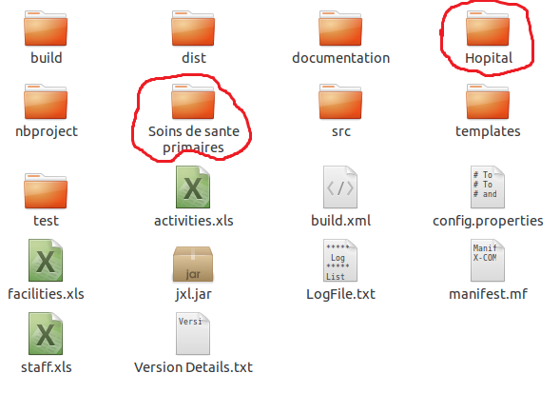**Figure 1: WISN Loader folder structure**

***(Templates)***

The Loader needs a template file per facility type. This template needs to contain all the activity standards, category allowances, individual allowances and the cadres per facility type. The Loader will use this template as a baseline to create the \*.wat file per facility. The templates (hospitals, clinics, with (.wat), etc.) are respectively saved under abovementioned folders.

Note that the above structure can be changing values in the property file *config.properties.* This file has some properties (only values can be changed, not property names) described below:

* ActivitiesFileName=activities.xls (change this to fit your activity statistics file name)
* StaffFileName=staff.xls (change this to fit your available staff file name)
* FacilitiesFileName=facilities.xls (change this to fit you facility list file name)
* TemplateFolderName=templates (change this to fit your template folder name)
* WISNFileExtension=wat (don’t change this)
  1. **Running the application**
     1. Running this application for the first time one has to navigate into the folder structure and just ensure that all the required files and folders as explained in section 4.1 are in place or according to your setting.

**When Templates (\*.wat) are modified**

When changes have been made to the templates, the new templates need to be moved to the respective folders and the old templates must be replaced. For example; if an activity is renamed for nurses in hospitals, these changes have to be made in the hopital.wat template, and you replace the old template with the updated template in the central folder.

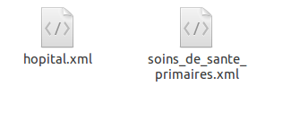

**Figure 2: The WISN facility templates**

**When excel files are modified**

In case of changes made to the excel file the ***content*** needs to be copied and used to replace the previous old ***content***. This excel files need to be saved in a *Microsoft Excel 97-2003 Worksheet (\*.xls)* format which allows the merging in xml. It’s very important that you do not just replace the files; otherwise the Loader cannot read the files.

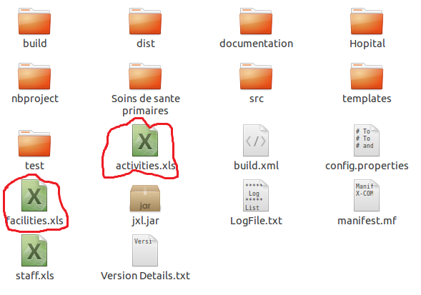

**Figure 3: The activities and facilities excel files (*Microsoft Excel 97-2003 Worksheet (.xls))***

* 1. **Sorting the facilities**
     1. When the Loader is done generation the WISN file for each of the facilities, one have to copy the \*.wat files from the default folder structure the into a folder structure that is easier for user to understand.

For example: files in the central folder into “Intermediate hospitals” folder, files in the provincial folder into into “District Hospitals”, etc. Also when you want to run summary reports, the WISN files for the facilities you want to compare has to be in the same folder so when you want to run a summary reports for all facilities within a region, all these WISN files have to be in the same folder. We used a specific naming convention that includes region and facility type to allow us to identify the type of facility by looking at the file name.

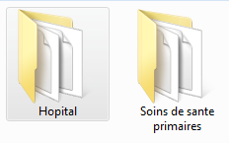

1. **Managing the input files** 
   1. **Managing Templates**

The templates need to be opened with WISN software for editing or modifying. This process need to be tracked to prevent using old templates which don’t have the latest activity standards. The name of the template should remain constant; the modified template should not be saved under a different name. We created a different folder for each time one of the activity standards changed to ensure the templates and the service statistics remain aligned.

* 1. **Activities**

This file contains all the service statistic data.

* 1. **Facilities**

This file contains all region and facility by classification.

* 1. **Staff**

This file contains current number of staff per cadre per facility.